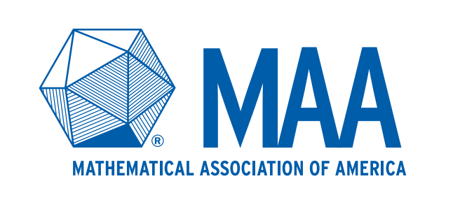
MAA Meetings Safety Requirements

Statement of Risk Assessment
Given the contagious nature of COVID-19, and that the CDC still recommends practicing social distancing, the Mathematical Association of America is asking for Section Meeting attendees to acknowledge the risk of attending a meeting in person.

To ensure the health and safety of all participants, the Mathematical Association of America requires that you acknowledge and accept the risks and requirements associated with participation in MAA Sectional meetings. Furthermore, MAA requires that attendees agree to abide by the host university’s protocols in accordance with CDC guidance.

Safety Requirements
When you arrive at the meeting location, you will be asked to affirm the safety requirements below:

- You do not currently exhibit, nor within the past fourteen (14) days have you experienced, any symptoms that the CDC has defined as associated with COVID-19, including (but not limited to): fever, chills, cough, new loss of taste or smell, and shortness of breath.

- You do not believe that you may have been exposed to a confirmed or suspected case of COVID-19 and have not been diagnosed with COVID-19 without being cleared as non-contagious by state or local public health authorities or the health care team responsible for your treatment.

☐I am following CDC recommended guidelines, and I agree to abide by the host university and MAA Section and MAA MathFest protocols.
More information on CDC guidance on Small and Large Gatherings at conferences.

