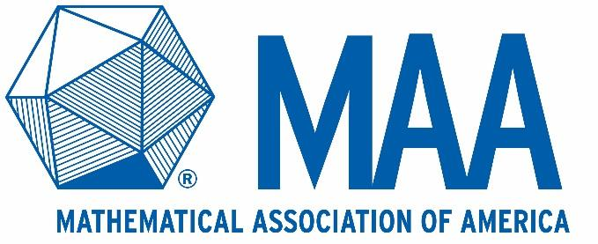

Job Description

Job Title: | Manager Development and Strategic Partnerships
Reports To: | Director of Communications and Development
FLSA Status | Exempt
Date Prepared | September 2019

Job Summary
The Mathematical Association of America is the world’s largest community of mathematicians, students and enthusiasts. We further the understanding of our world through mathematics because mathematics drives society and shapes our lives. Our mission at the MAA is to advance the understanding of mathematics and its impact on our world and we do so through our values of, Community, Inclusivity, Communication, and Teaching and Learning.
The Mathematical Association of America is seeking a development professional to join its growing team. Working at the MAA means that you will be joining a dynamic and dedicated team where your contributions will be encouraged and appreciated. We are located within a desirable Washington, DC location.

This individual should have a core understanding of nonprofit fundraising best practices and trends. The ideal candidate will be able to implement development plans, and meet quarterly and annual goals. This candidate will also bring creativity, insight, motivation and an entrepreneurial mindset to the position.

Job Responsibilities
- Collaborate with the Director of Communications and Development and the external development team in the planning and implementation of fundraising strategies
- Streamline the department’s operations and systems, including the donor database, prospect and campaign reporting, and financial tracking and reporting
- Help create customized donor relations materials to secure new donor relationships and maintain support from existing donors
- Oversee the creation of development materials such as direct mail and digital appeals, printing and mailings, and managing digital content for the website and social media
- Support departmental prospect research for both the individual and corporate giving, including for development events
- Identify new funding prospects and conduct proactive outreach
- Collaborate with other departments to identify storytelling opportunities and clear messages that align with the associations strategic fundraising goals
- Produce reports to support the department needs, including database, contact records, financial, prospect pipeline, and gift analyses
- Provide project management to support the department, including meeting and events preparation, internal coordination and administration, and team operations

Supervision
- As part of the restructuring of MAA development efforts, will lead recruitment and hiring, and then supervise, a development coordinator, overseeing their work on events, administration and logistics
- Manage relationships with other internal association departments to support fundraising events, materials creation and more
- Manage relationships with external agency and other vendors as needed

Qualifications
To perform this job successfully, an individual should possess the knowledge, skills, and abilities listed and meet the amount of education, training and/or work experience required.

- Experience with nonprofit database management and basic nonprofit finance and accounting required
- Prior supervisory experience a plus
- Experience with Microsoft Office Suite and CRM software
- Excellent organizational, written and verbal communication, and interpersonal skills required. Must be self-motivated, detail-oriented, flexible, and able to meet tight deadlines and work independently as well as collaboratively.
- Bachelor degree required
- 3-4 years of work experience in a professional fundraising setting required
- Event management experience is a plus

Working Conditions
- General office
- Occasional evening and weekend work
- Travel required up to 25% of time

Benefits
- Highly competitive robust benefits package that includes 15 days of accrued vacation per year for the first three years, 12 accrued sick days per year and 14 paid holidays per year.

Equal Opportunity Employer

